Design: Code Extractor for Videos

Persona
“Coding” Katie  20 & eager to learn more coding | 👩🏽‍💻
Aspirations  - Create technology to help connect people  - Champion accessibility |  | Problems/Friction  - Learning new software (especially if it has keyboard shortcuts that get in the way of custom)
Background
After gaining her first laptop at age 7 from her aunt, Katie started to spend a lot of time tinkering with technology. She learnt side by side with her aunt who worked in coding. The two bonded over their shared interest and Katie’s aunt taught her how to use computers especially at parts were vision was required (Katie is blind). Over the years she learnt she could create small software and applications for her daily life, be it a counter while playing her piano or retrieving data for her daily trips to school.

User stories
(2-3 and documented in GitHub and design notes)

- As Katie, I want to learn coding from a video, so that I can learn alongside my classmates.
- As Katie, I want to pause a coding tutorial video and extract text from it, so that I can access the code onscreen and learn.

Wireframe

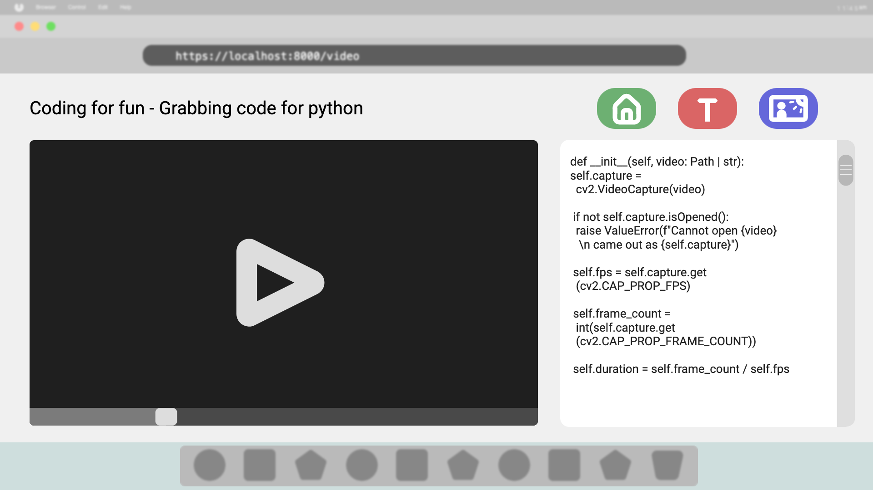

Personalisation
The ability to automatically copy text to the clipboard from a given frame

Sign off

Links
GitHub links to the following:
◦ Persona, user stories, and wireframes: Current document
◦ Summary of meeting with assessor: https://github.com/HeyWray/tw-adv-ocroo-2025/blob/main/design/design-evidencing-guide.md

Build
• Your build uses a client/server design
• Your build selects technology appropriate for the design and organisational needs
• Your build includes multimedia support (video playback or parsing accepted):
briefly describe what it is and link to 1-2 key classes implementing this capability

Video playback: implemented with simple_api > video_path & via streamlites video player in the main.py’s video_player()

• Your build includes an attempt to add client-side validation on at least one occasion:
briefly describe what it is and link to 1-2 key classes implementing this capability

None

• Your build includes an attempt to add personalisation on at least one occasion:
briefly describe what it is and link to 1-2 key classes implementing this capability

The ability to automatically copy the outputted text to the user’s clipboard. Found in main.py > video_player()
#copy to clipboard if true
if st.session_state["copy_text"]:
clip.copy(st.session_state["video_text"])

#Customisation, automatically copy text to clipboard
with txtcol2:
if st.checkbox("Automatically copy text to clipboard", width="stretch"):
st.session_state["copy_text"] = True
else:
st.session_state["copy_text"] = False

• You have reviewed your build and fit with design on at least one occasion with your assessor

